**USmart Go User Manual**

1. **Download the App**

Search "USmart Go" on Apple App Store or Google Play for your iOS/ Android device.

1. **Basic Setting**
2. **Create an account**

Launch the "USmart Go" App and register an account, you can register by your phone number or email address.

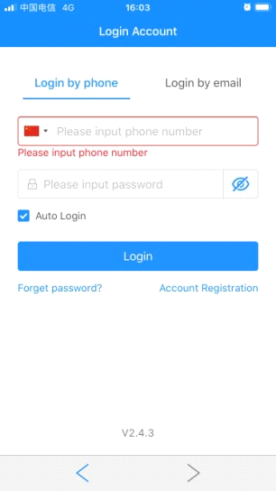 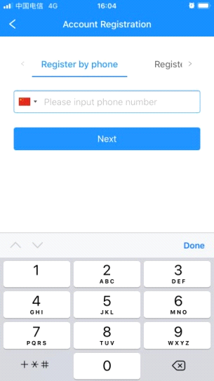

1. **Setting Security Password**

You'll need to setup a security password for two-step verification. Following the steps: Menu sidebar -> "My Settings" -> "Set security password".

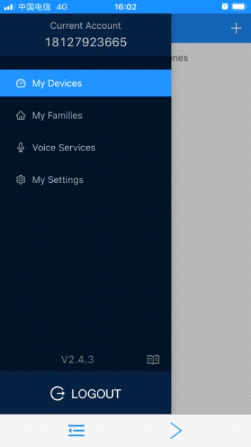 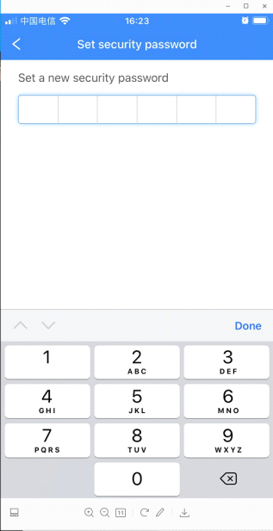 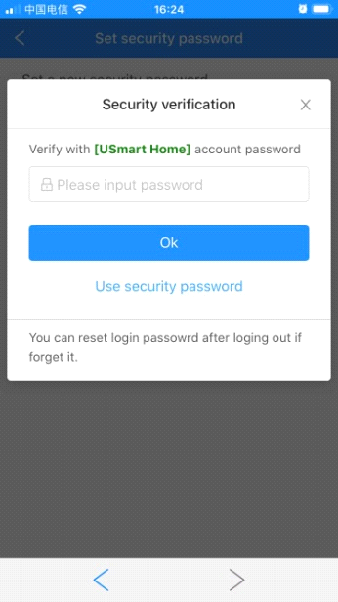

1. **Create a Family**

Every device associated with a Family, follow the steps to create a family: Menu sidebar -> "My Families" -> "+" button.

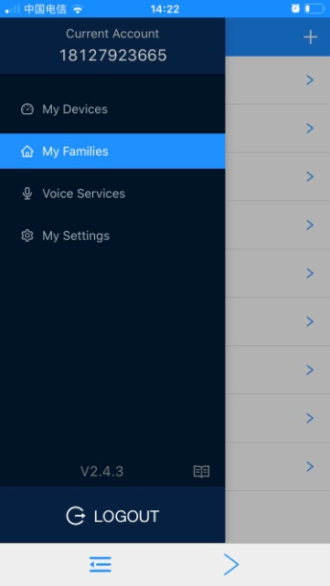 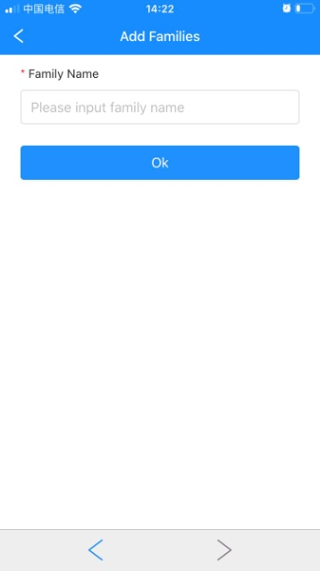

1. **Connect the Lock**

Launch the App, click the "+" button at the upper right corner, choose "Add Wi-Fi Device" item, you'll see a screen as below:

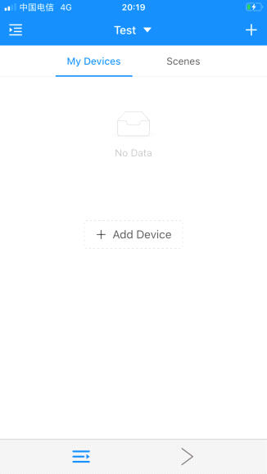 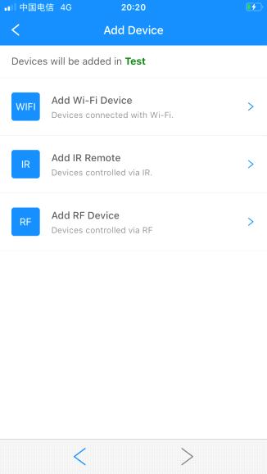 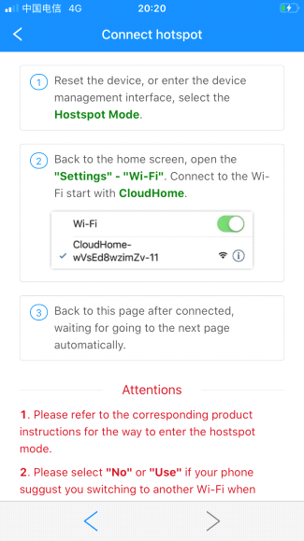

* Now press the "*#" button on the lock, verify the admin password and enter the admin interface. Choose "System Setting" -> "Function Set" -> "Net Config" to enter the network pair mode.
* Go to the WLAN setting on your phone, and connect to the Wi-Fi with the name as "CloudHome-XXXX-16".

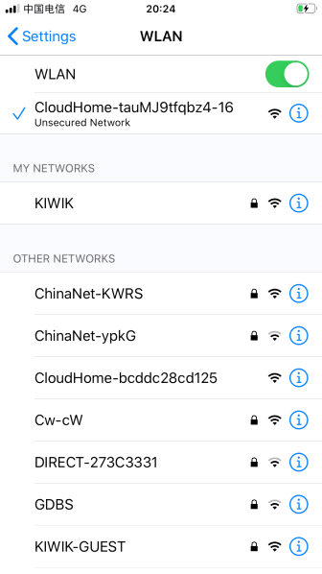

* Go back to the App, choose the Wi-Fi of your home and input the password. Click "Search device" and wait for connection.

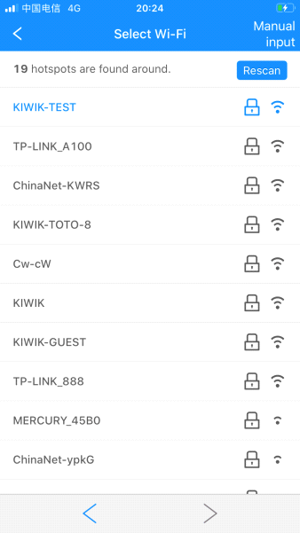 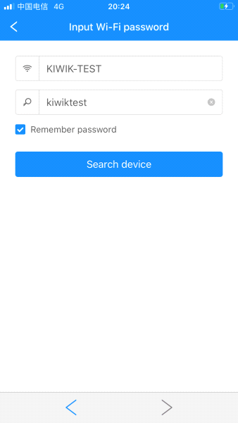 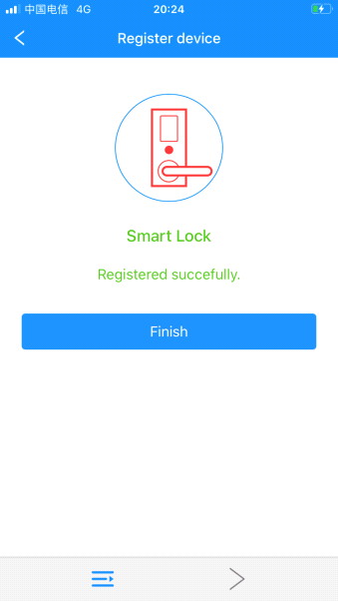

1. **USmart Go Function**
2. **Remote Unlock**

After pressing "3#" on the lock to trigger a remote unlock request, you'll see a popup window on our app, then enter your security password to unlock.

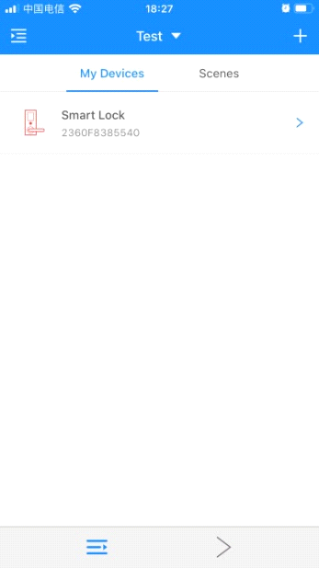 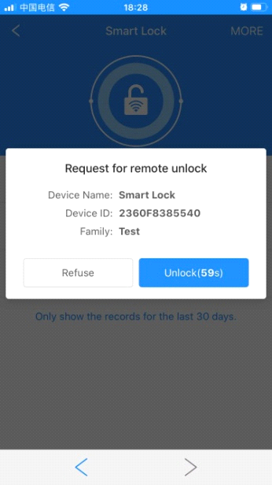 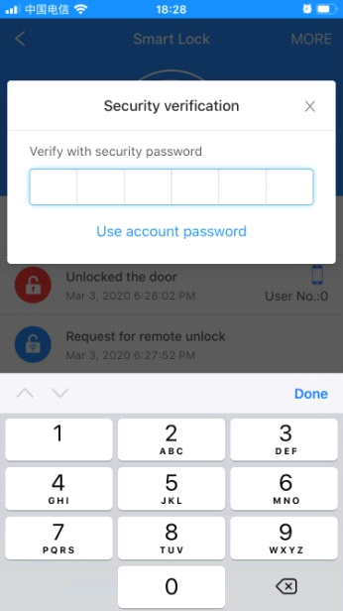

1. **Rename the User**

Click the event list to rename the user.

